The Service Records of Mathematics Department during 2019 – 2023
Satak Raut
Mob :9735695363
B.Sc(Mathamatics)
Year of passing:

Paschim Sripatinagar DR.B.C.ROY Memorial Vidyapith

Rs.7100-37600/month(GP-4100)

Date of Joining:
12/12/2019

Rathindra Nath sau

Mob:
7479186175)

B.Sc(Mathamatics)
Year of passing:
2021

INDIA POST (06289857707)

Rs.10000-24470/month

Date of Joining:
21/09/21

Madhusudhan Midya
(Mob.- 7431069236)

B.Sc(Mathamatics)
Year of passing:
2021

INDIA POST (06289857707)
Rs.13049/month

Date of Joining:
22/06/2020

Sumana Mandal

Mob.- 6295623557
B.Sc(Mathamatics)
Year of passing:
2021

INDIA POST (06289857707)

Rs.16262/month

Date of Joining:

Sayani Roy

(Mob.- 9609244101)

B.Sc(Mathamatics)
Year of passing:

INDIA POST (06289857707)
Rs.16242/month

Date of Joining:

Anuradha Sau  (Mob.-  9875612309)  B.Sc(Mathamatics)  Year of passing:2020  INDIA POST)  Rs.16242/month  Date of Joining:01.06.2020 | 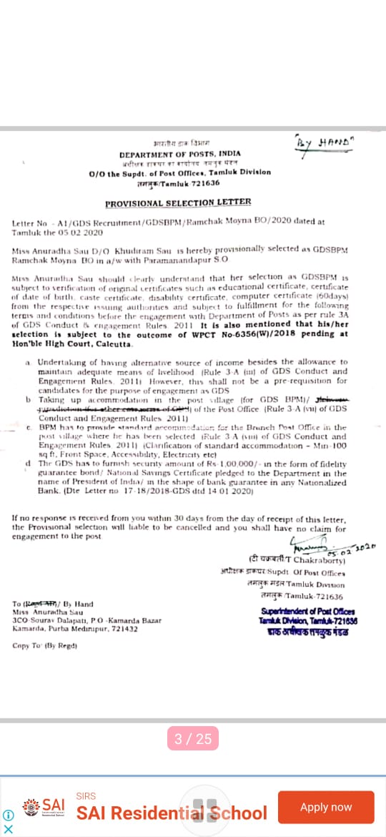
Santanu Giri

Mob:9382285635

B.Sc(Mathamatics)
Year of passing:

Indian Army
Rs.27500/month

Date of Joining:

Suman Dhal
(08967207432)

B.Sc(Mathamatics)
Year of passing:

INDIA POST (06289857707)
Rs.16242/month

Date of Joining:

Swathi Maikap
(7063506590)

B.Sc(Mathamatics)
Year of passing:
2022(Running)

INDIA POST (06289857707)

Rs.16242/month

Date of Joining:
09/08/2021

Paramita Bhunia

B.Sc(Mathamatics)
Year of passing:

Assistance Teacher
Rs.29710/month

Date of Joining:
27.07.2022

Tanusri Roy
Mob:
B.Sc(Mathamatics)
Year of passing:2019

Computer Instructor(Khejuri Guruprasad balika vidyaniketan)

Rs.8000/month

Date of Joining:
10/12/2019

Piu Maity
Mob:8617321608
Shyamchak,
Khejuri
Purba Medinipur
WB-721430
B.Sc(Mathamatics)
Year of passing:
2020

Bandhan Bank
Rs.25000/month

Date of Joining:
04/07/22

Gouri sankar Mandal

Mob:8348229707
M.Sc(Mathamatics)

Year of passing:
2022

Constable(CISF Unit DSP Durgapur) West Bengal
Rs.21700/month

Date of Joining:
28/12/2022

Somsankar Mandol

Mob:7679173969
B.Sc(Mathamatics)
Year of passing:
2022(Running)

Peon (PNB-GARKAMALPUR)
Rs.25767/month

Date of Joining:
01/09/22

Rabindranath Bhoj

Mob:6294097831

M.Sc(Mathamatics)
Year of passing:

2019

Teaching Assistant in Mathematics (IISER TIRUPATI)
Rs.16000/month

Date of Joining:19.11.2022

Rintu kar
Mob:9609500362

M.Sc(Mathamatics)
Year of passing:
2020

Teacher
(PATHFINDER HS PUBLIC SCHOOL ,MIDNAPORE) 9147002513

Rs.32000/month

Date of Joining:
25/4/22

Subhajit Giri
Mob:9775222968
M.Sc(Mathamatics)

Year of passing:
2020

Teacher as Foundation academy ,IIT Patna,Bihar

Rs.35500/month

Date of Joining:09.02.2022

Sudip Misra
Mob:9064358389
M.Sc(Mathamatics)
Rs.14586/month

Year of passing:

2020

Date of Joining:
01/04/2022

Sabyasachi Maji
6295136648
B.Sc(Mathamatics)
Year of passing:
2022

Smart Value Indepandent Business asssociation

Rs.10000/month

Date of Joining:
26/02/22

Nandan Maity
Mob:9749997855
Year of passing:

M.sc Mathematics

Cyber Security

Rs.56182/month

Date of Joining:
27/08/2021

Debraj Manna

B.sc Mathematics
SACT in Mugberia Gangadhar Mahavidyalaya

Madhumita Sahoo

B.sc Mathematics
SACT in Mugberia Gangadhar Mahavidyalaya

Hiranmoy Manna

B.sc Mathematics
SACT in Mugberia Gangadhar Mahavidyalaya

Tanmoy Mal
Mob:9749997855

B.Sc in Mathematics (Hon.)

Teacher as Foundation Academy, IIT Patna Bihna

Rs.10000/month

Date of Joining:
01.09.2022

Chayan Pradhan:  M.Sc in Mathematics 2021  Dept of Mathematics  Mugberia Gangadhar Mahavidyalaya  Mob. 7407632393  IT staff (India Coast Guard)  Haldia Pm WB 721  Ph. 9674436539/8335826861  Rs. 14740/Month  Date of Joining:  10.04.2022 | 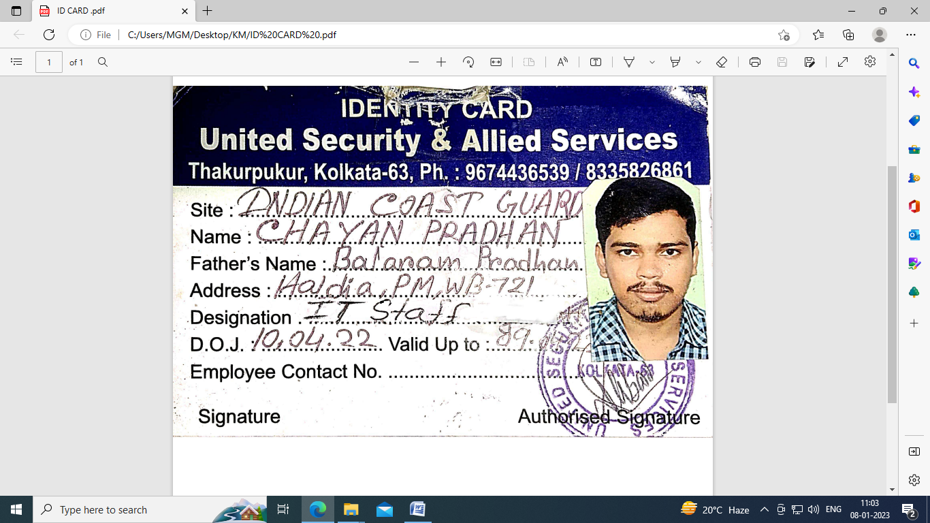
 | 